**Flieger-My Buddy**

Motors and their Rotation

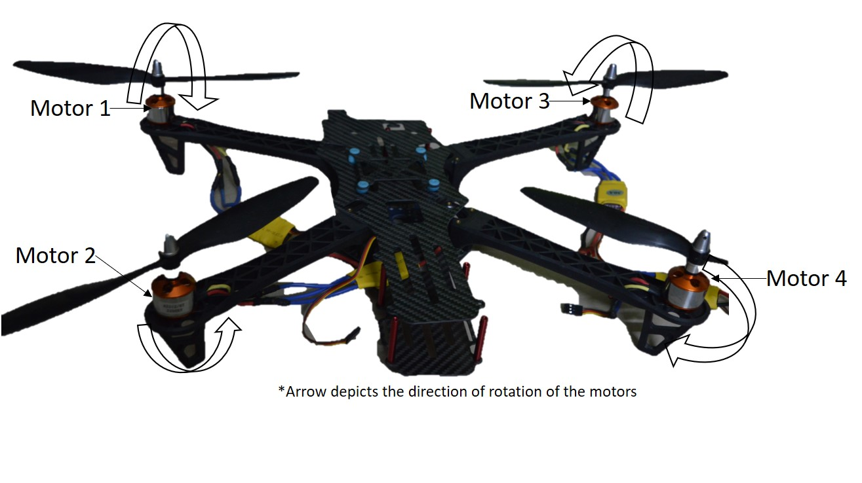

**RPM-Revolution Per Minute**

**Throttle: Upward-:**

Motor 1+Motor 4-Increase RPM

Motor 2+Motor 3-Decrease RPM

**Throttle: Downward-:**

Motor 2+Motor 3-Increase RPM

Motor 1+Motor 4-Decrease RPM

**Pitch: Forward-:**

Motor 3+Motor 4-Increase RPM

Motor 1+Motor 2-Decrease RPM

**Pitch: Backward-:**

Motor 1+Motor 2-Increase RPM

Motor 3+Motor 4-Decrease RPM

**Yaw: Left-:**

Motor 1+Motor 4-Increase RPM

Motor 2+Motor 3-Decrease RPM

**Yaw: Right-:**

Motor 2+Motor 3-Increase RPM

Motor 1+Motor 4-Decrease RPM

**Roll: Left-:**

Motor 2+Motor 4-Increase RPM

Motor 1+Motor 3-Decrease RPM

**Roll: Right-:**

Motor 1+Motor 2-Increase RPM

Motor 2+Motor 4-Decrease RPM